**Testing**

**Introduction:**

Software Testing is a method to assess the functionality of the software program. The process checks whether the actual software matches the expected requirements and ensures the software is bug-free. The purpose of software testing is to identify the errors, faults, or missing requirements in contrast to actual requirements. It mainly aims at measuring the specification, functionality, and performance of a software program or application.

**Why Software Testing is required :**

* Defects can be identified easily to mitigrate future risk.
* It helps to Improves quality of software.
* It helps to check the customer requirements meet the added requirements in software and increased customer satisfaction.
* Software testing ensures reliability, security, and high performance which results in saving time, costs, and customer satisfaction.
* Helps with scalability of the software.
* It helps to save time and money .

**Different Levels of Software Testing**

Software level testing can be majorly classified into different levels:

Unit Testing: Unit testing is a level of the software testing process where individual units/components of a software/system are tested. The purpose is to validate that each unit of the software performs as designed.

Integration Testing: Integration testing is a level of the software testing process where individual units are combined and tested as a group. The purpose of this level of testing is to expose faults in the interaction between integrated units.

Blackbox testing:

Black-box testing is a software testing technique where the tester doesn't have knowledge of the internal workings of the system being tested. Instead, they focus on testing the functionality of the system based solely on

its inputs and expected outputs.

|  |  |  |  |  |
| --- | --- | --- | --- | --- |
| SR.NO | TEST CASES | CONDITIONS | INPUTS | EXPECTED RESULTS |
| 1 | User Login | User enters incorrect Username or Password | Correct Username: Admin  Entered value: admin  Or correct input  Password:123456  Entered value:123789 | Authentication Falied. Incorrect Username or Password. |
| 2 | User Login | User enters correct Username or Password. | Correct Username: Admin  Entered value: Admin  Or correct input  Password:123456  Entered value:123456 | Redirect to the Dashboard selected Module. |

INCORRECT

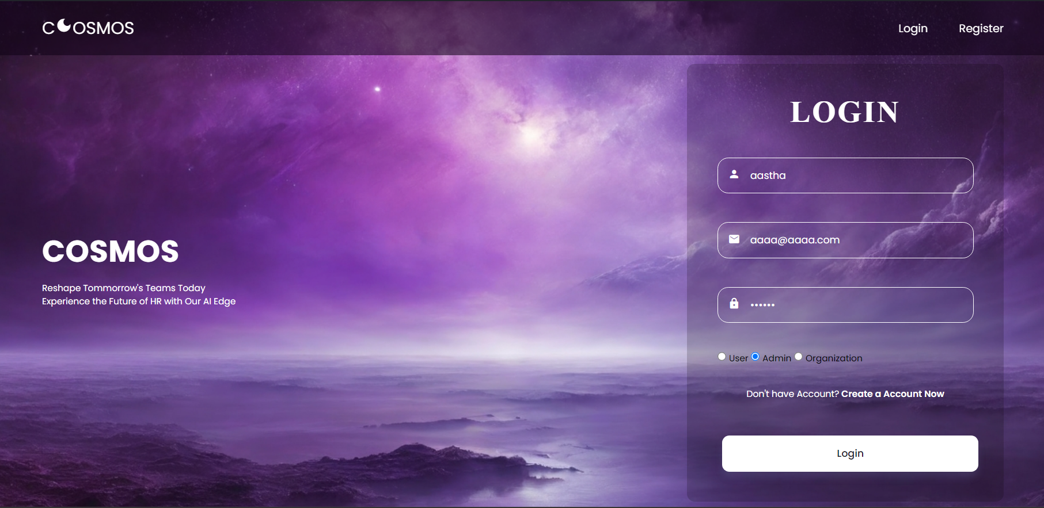

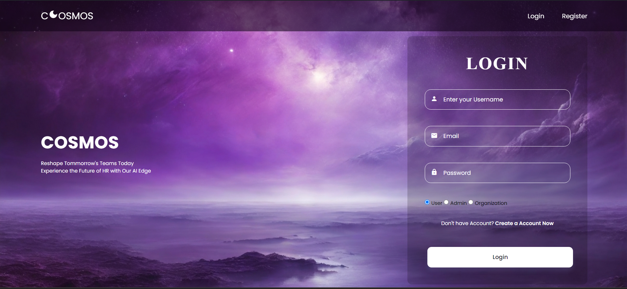

CORRECT

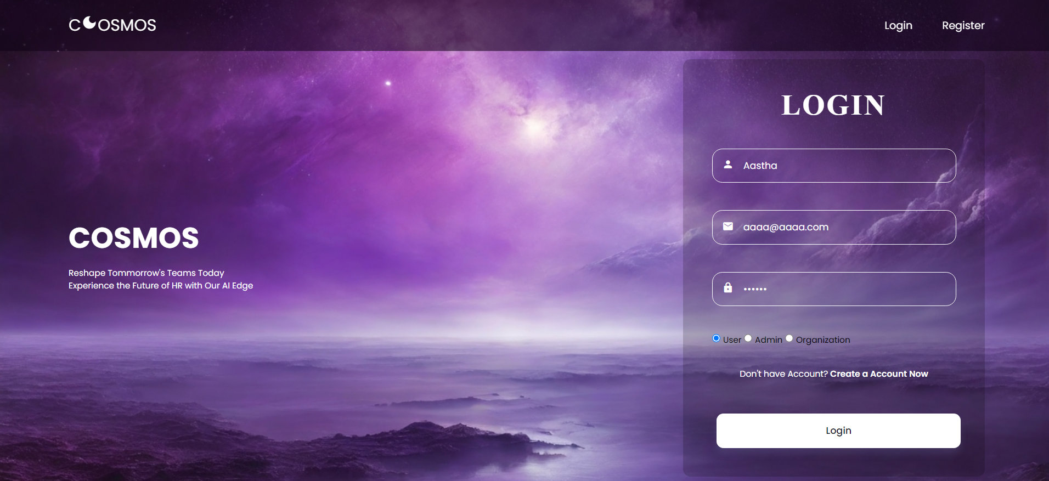

Successful redirect to dashboard

